Table of Contents

- Introduction ...............................................................................................................................2
- Problem Statement ....................................................................................................................2
- Objectives....................................................................................................................................2
- Dataset Description ...................................................................................................................3
Dataset Distribution ....................................................................................................................3
- Existing Solutions ......................................................................................................................4
- Proposed Methodology ..............................................................................................................4
  - Data Preprocessing ..............................................................................................................4
  - Model Architecture ..............................................................................................................4
  - Training and Validation Process ..........................................................................................4
- Tools and Technologies..............................................................................................................5
- Experimental Results ................................................................................................................5
  - Overall Performance Summary ...........................................................................................5
  - Class-wise Performance .......................................................................................................5
  - Sample Output Predictions ..................................................................................................6
  - Confusion Matrix ............................................................................................................... 10
  - Training and Validation Curves......................................................................................... 11
- Evaluation Metrics .................................................................................................................. 12
- Discussion .............................................................................................................................. 12
  - Result Visualization ............................................................................................................. 12
- Conclusion ............................................................................................................................. 13
- Future Work ......................................................................................................................... 13
- References ............................................................................................................................. 13

1. Introduction
With the rapid growth of artificial intelligence, especially generative models such as GANs and diffusion models, AI-generated images have become increasingly realistic. These images are widely used in media, entertainment, advertising, and social platforms. However, the rise of such technology has also introduced serious challenges, including misinformation, deepfakes, digital forgery, and misuse of synthetic media. Distinguishing between AI-generated images and real images has therefore become an important research problem.
This project focuses on developing an automated deep learning–based system that can accurately classify images as either AI-generated or real. By leveraging powerful convolutional neural networks and transfer learning techniques, the system aims to detect subtle visual patterns that are often difficult for humans to identify.

2. Problem Statement
AI-generated images are becoming increasingly indistinguishable from real photographs. Manual identification of such images is unreliable, time-consuming, and prone to error, especially when large volumes of data are involved. Traditional image processing and machine learning methods rely on handcrafted features, which often fail to capture the complex patterns introduced by modern generative models.
Therefore, there is a strong need for an automated and intelligent solution that can effectively differentiate between AI-generated and real images with high accuracy and reliability.

3. Objectives
The main objectives of this project are:
- To design and implement a deep learning–based image classification system
- To distinguish AI-generated images from real images using convolutional neural networks
- To utilize transfer learning for improved performance and faster convergence
- To evaluate the model using standard classification metrics
- To demonstrate the effectiveness of deep learning in synthetic media detection

4. Dataset Description
The dataset used in this project is obtained from a publicly available Kaggle repository titled “AI-Generated Images vs Real Images”. The dataset contains images belonging to two classes:
- AI-Generated Images
- Real Images
The images vary in resolution, content, and visual characteristics, closely resembling real-world data.

Dataset Distribution
- Class 0 (AI-Generated Images): 539 samples
- Class 1 (Real Images): 434 samples
The dataset is split into training and testing sets using a stratified approach to maintain class balance.

5. Existing Solutions
Existing solutions for detecting AI-generated images include manual inspection, metadata analysis, and classical machine learning models based on handcrafted features such as texture, noise patterns, and frequency analysis. These approaches often struggle with generalization and fail when exposed to images generated by unseen models.
Recent research has shown that deep learning models, particularly convolutional neural networks, outperform traditional methods by automatically learning complex and hierarchical features directly from image data.

6. Proposed Methodology
The proposed system uses a deep learning–based binary classification approach. A pre-trained convolutional neural network is fine-tuned to classify images as AI-generated or real. The overall workflow consists of data preprocessing, model training, validation, and evaluation.

6.1 Data Preprocessing
Before training, all images are resized to a fixed resolution to ensure uniform input dimensions. Pixel values are normalized to stabilize and speed up training. Data augmentation techniques such as random horizontal flipping are applied to improve generalization and reduce overfitting.

6.2 Model Architecture

The project uses EfficientNet-B7, a state-of-the-art convolutional neural network architecture known for its high accuracy and efficiency. Transfer learning is applied by using pre-trained ImageNet weights. The final fully connected layer is modified to output a single neuron for binary classification, followed by a sigmoid activation function.

6.3 Training and Validation Process
The dataset is split into training and testing sets with an 80:20 ratio. The model is trained using the Binary Cross-Entropy with Logits Loss function and optimized using the Adam optimizer. Early stopping is implemented to prevent overfitting and to restore the best-performing model weights.

7. Tools and Technologies
- Programming Language: Python
- Deep Learning Framework: PyTorch
- Model Architecture: EfficientNet-B7
- Development Environment: Google Colab
- Libraries: NumPy, Pandas, Matplotlib, Seaborn, Scikit-learn, Torchvision, Torchmetrics, PIL

8. Experimental Results
The trained model demonstrated strong performance in distinguishing AI-generated images from real images. Both training and testing results indicate effective learning and generalization.

8.1 Overall Performance Summary
- Training Accuracy: High and stable across epochs
- Testing Accuracy: Strong performance on unseen images
- Loss values show steady convergence with early stopping

8.2 Class-wise Performance
The model achieves balanced precision and recall for both AI-generated and real image classes, indicating reliable classification without significant bias toward any class.

8.3 Sample Output Predictions (0: AI, 1: Real)
The system outputs a predicted class label (AI-generated or real) along with a probability score. This probability provides insight into the confidence of the model’s prediction.

Sample Image Input Real:

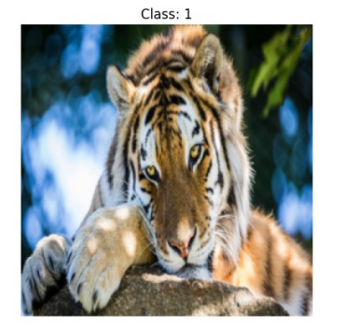

Sample Image Input AI:

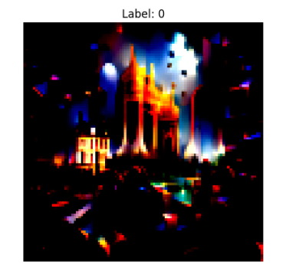

The model outputs the predicted AI and real class.

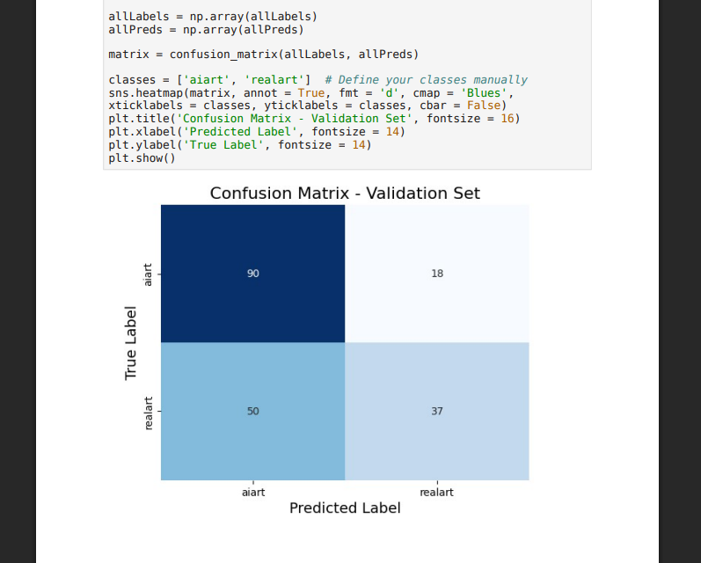
8.4
Confusion

Matrix

The confusion matrix shows a high number of correct predictions along the diagonal, with minimal misclassification between the two classes. This confirms the effectiveness of the proposed approach.

8.5 Training and Validation Curves
Training and validation accuracy and loss curves demonstrate stable convergence. The gap between training and validation performance remains small, indicating minimal overfitting.
Training vs Validation loss graph:

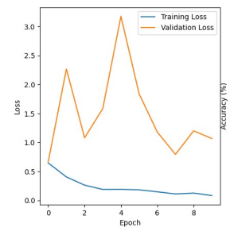
Validation Accuracy graph:

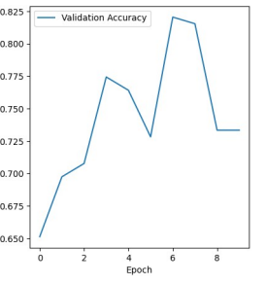
The curves show stable convergence and minimal overfitting throughout the training process.

9. Evaluation Metrics
The model performance is evaluated using the following metrics:
- Accuracy: Overall correctness of predictions
- Precision: Correctness of positive predictions
- Recall: Ability to identify actual positive samples
- Confusion Matrix: Visual representation of classification results

10. Discussion
The experimental results highlight the effectiveness of deep learning and transfer learning in detecting AI-generated images. EfficientNet-B7 successfully captures subtle visual artifacts that differentiate synthetic images from real ones. Compared to traditional methods, the proposed system provides higher accuracy and better generalization.
However, performance may vary when tested on images generated by newer or unseen generative models. Dataset diversity and size also play a crucial role in model robustness.

11. Conclusion

This project successfully presents a deep learning–based approach for distinguishing AI-generated images from real images. The use of EfficientNet and transfer learning enables high accuracy and reliable performance. The system can be used as a supporting tool to combat misinformation, detect deepfakes, and enhance digital content authenticity verification.12. Future Work
Future enhancements may include:
- Training on larger and more diverse datasets
- Testing against images generated by advanced diffusion models
- Integration of explainable AI techniques such as Grad-CAM
- Deployment as a web or mobile application for real-time detection

13. References
- AI-Generated Images vs Real Images Dataset – Kaggle
- PyTorch Documentation
- EfficientNet: Rethinking Model Scaling for CNNs

